# C3P０连接池

## 概述

主流开源连接池，在Hibernate和Spring 都提供对C3P0连接池支持

去下载c3p0 开发包 http://sourceforge.net

将c3p0的jar 复制WEB-INF/lib下

## 手动

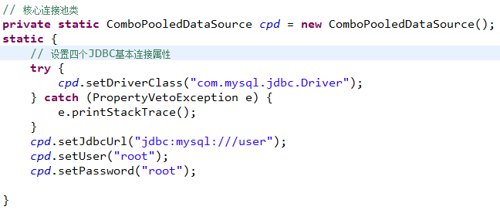

## 自动1- c3p0-config.xml

### c3p0-config.xml

<?xml version=*"1.0"* encoding=*"UTF-8"*?>

<c3p0-config>

<default-config>

<property name=*"driverClass"*>com.mysql.jdbc.Driver</property>

<property name=*"jdbcUrl"*>jdbc:mysql:///user</property>

<property name=*"user"*>root</property>

<property name=*"password"*>root</property>

</default-config>

</c3p0-config>

ComboPooledDataSource comboPooledDataSource = new ComboPooledDataSource(); 会自定加载配置文件

### jdbcUtils



## 自动2- c3p0-config.xml

### c3p0-config.xml

<?xml version=*"1.0"* encoding=*"UTF-8"*?>

<c3p0-config>

<named-config name=*"javamyfirst"*>

<property name=*"driverClass"*>com.mysql.jdbc.Driver</property>

<property name=*"jdbcUrl"*>jdbc:mysql:///user</property>

<property name=*"user"*>root</property>

<property name=*"password"*>root</property>

</named-config>

</c3p0-config>

### jdbcUtils



## 自动3—c3p0.properties

### c3p0.properties

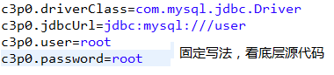

### jdbcUtils

